Information regarding the requirements of the Pressure Equipment Directive 2014/68/EU and In Service Inspection

Dovre Sertifisering AS

GUIDELINE

GL-DSE-2020-009 use of a KeyLock system for isolating a safety valve

|  |  |
| --- | --- |
| Document title: | Guideline for use of an isolating a safety valve KeyLock system |
| Client: | All |
| Client order: |  |
| DSE number: | GL-DSE-2020-009 use of a KeyLock system for isolating a safety valve |

Contents

1. Information and background 2

2. When is remote inspection allowed 2

3. Registration of inspection 3

# Information and background

This review and approval Is written to verify the use of keylock valve systems in safety valve relief systems.

KeyLock systems are widely used in the process and offshore industry as a way to safely isolate energy sources from systems in use.

The systems will prevent human errors and shall guide operator by predefined valve operating sequences to the correct locking and unlocking sequences. For the a set of unique keys are used that only allow the correct valves to be opened or closed in a predefined order.

Thus creating a safer environment and reduce erroneous routines.

# Can Keylock systems be used in boiler relief systems?

The use of KeyLock systems in steam boiler relief systems is not allowed. EN12953-8 clearly states that there shall not be any valve placed in the pressure relief line of a steam boiler.

*“ There shall be no shut off devices between the boiler and its safety devices or between the safety device and their points of discharge.”*

Isolating these lines for maintenance is therefore done by placing a blind spade in the valve line.

ASME BPVC. VIII D1 allows the use of stop valves in the upstream and / or downstream line of the discharge line. The relevant points for using valves in discharge piping are to be found in attachment M-5.7 of the ASME BPVC VIII Division 1.

# Keylock systems working principle

The keylock system principle is as follows. To prevent erroneous locking out of systems a set of keys is used to open and close the discharge line of å pressure vessel. These keys are not interchangeable and only 1 set Is available.

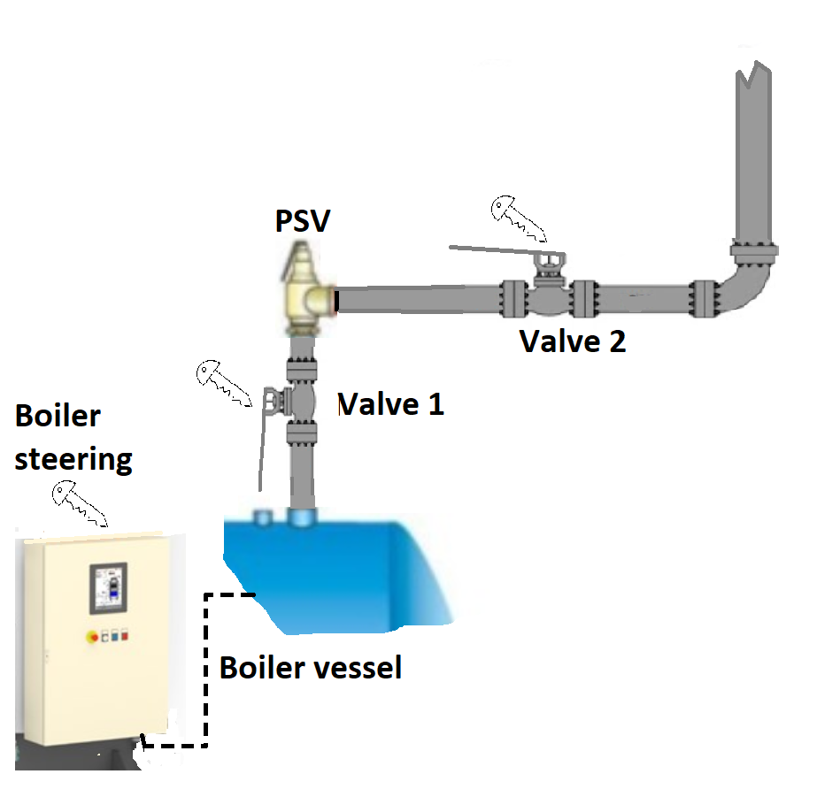

Figure 1 Basic principle

How does this in work in practice?

Each step in the keylock system is done with a specific key. This is best explained in an example.

Table 1 Key colours

|  |  |  |
| --- | --- | --- |
| **Component** | **Key 1** | **Key 2** |
| Power K1 | Main key | Orange |
| Va | Light blue | Orange |
| Vb | Green | Light blue |
| Power K2 | Main key | Red |
| Vc | Light green | Dark blue |
| Vd | Dark blue | Red |

Regard the system in figure 2 which comprises of 2 boiler vessels Kjel 1 and Kjel 2. In the case below the PSV K2 is to be locked out for maintenance.

Step 1:

The first step is to retrieve the key that is placed in the Boiler steering system “power K2”. This key can only be retrieved if the power of the boiler is disconnected otherwise the key can not be removed from its lock. The main key is placed and the power is turned off. At this point the red key is released.

Step 2:

The key (red) is then placed into valve Vd, this valve has now two keys 1 from Power K2 and 1 already in Vd (Figure 3). Valve Vd is closed and the key Vd (Dark blue) is released and can be removed. This means that at this point the valve is locked and Key Vd (Dark blue) is free.

Step 3:

Key Vd is taken to valve Vc. The key Vd is placed in valve Vc and the valve can be closed key Vc (light green) is removed after the valve is locked.

Step 4:

Key Vc (Light green) is then taken to the LOTO box or another secure place and the system is signed off for being isolated.

Opening the system means the procedure needs to be performed in reversed order.

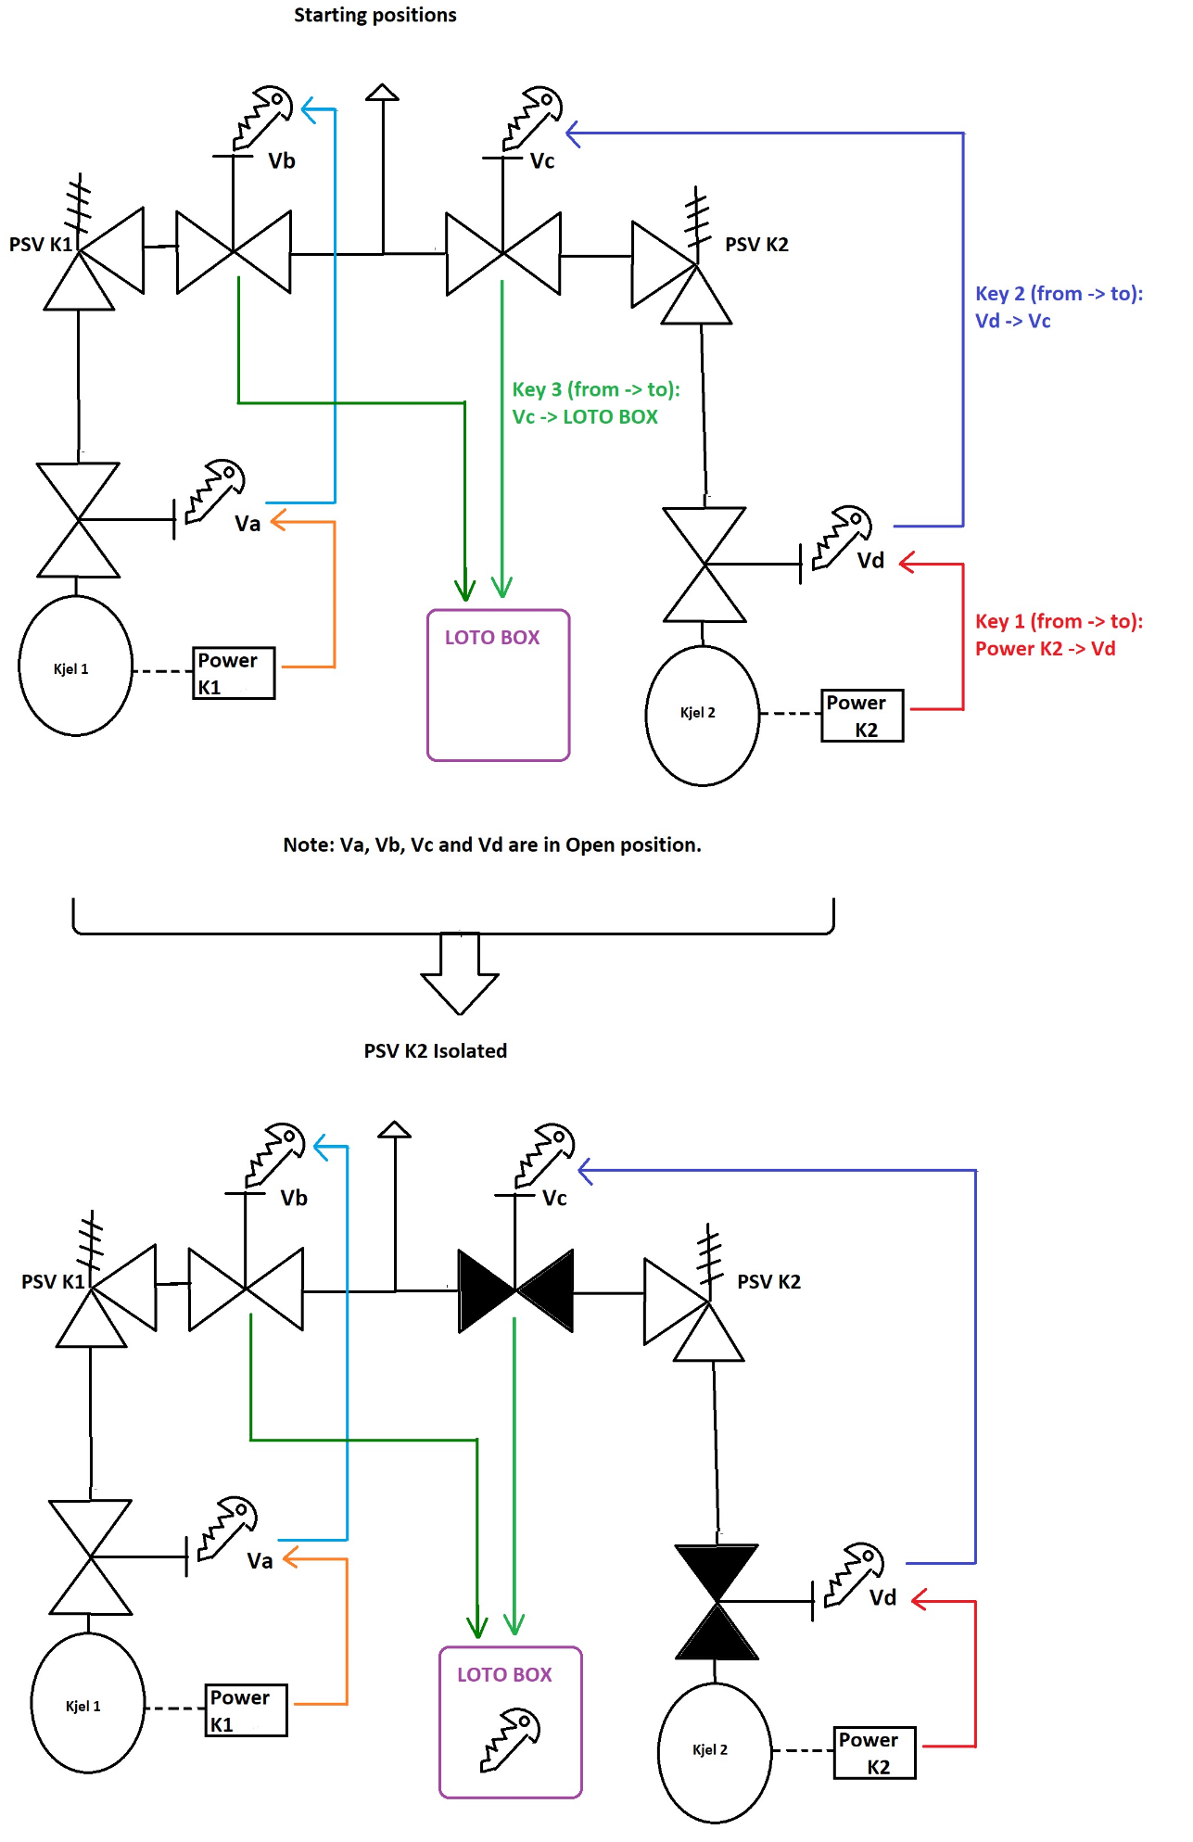

Figure 2 Working principle

# Validation of usage

As presented in §2 the general standards for boilers do not allow the use valves in the discharge lines of boilers. This means that the Keylock systems or other type of closing valves can’t be used in discharge lines out from the harmonised standards for these types of equipment.

Based on the received information this type of system has a high safety factor. The keys are not interchangeable and valves or other locked equipment can not be operated without a key or with the wrong key inserted. Operating the system requires access to the correct keys and knowledge of the system itself.

The system is widely used in the offshore industry and has proven his reliability. The system has a safety performance level “d” (ISO13849-1) meaning a probability of dangerous failure per hour (/h) ≥10-8 and < 10-7 thus a 0,000001% to 0,00001% rate.

# Conclusion

DSE has reviewed the key lock system and the combined failure rate. The result of this validation indicates that this system has a low probability of failure in normal operating situations.

It is important that the implementation of such systems is performed correctly so that every step in the lock out procedure is correct. If the sequence is incorrect the safety of this system is not secured. This shall be taken into account in the risk analysis of the system being secured by the key lock system.

Based on the information received on the system Dovre Sertifisering AS can approve the use of this type of lock out system in boiler discharge systems.

However approval will be needed and is reviewed on a case to case basis.

# Information required before approval

The following information is required before the Keylock system can be approved for implementation in a safety valve system.

* Risk analysis
* Calculation that the chosen system at least has the same safety level as required in the standards
* Description of the chosen system
* Procedures for usage